Tute Platform User Guide

Intro
This guide is aimed primarily IT personnel who maintain the computer systems where Tute is deployed and teachers who will be supervising the students on lessons. It is important that these personnel understand the platform and recognise they have a responsibility to maintain functionality at their end. Initial testing is carried out in every school/academy prior to Tute being deployed. This testing ensures the there is connectivity at a network level. The test does include making sure testing the audio bridge, however this is on an individual machine. It is the IT personnel that need to ensure the microphones and headphones are working throughout the classrooms that Tute lessons will be held in

Layout
The platform is split into 4 main parts. These are users/audio, instant chat, video and interactive whiteboard. These parts are dynamic in size and can be arranged within the browser how the user sees fit.
This Button rearranges the windows inside the browser window to their default positions and size. So if the browser window is resized and the boxes are moves around this button will reset them. This is very important because sometime the boxes can overlap and are hidden.

Users
The users section is comprised of users who have joined the session and users who have joined and who have shared their microphones, these users are placed in a listeners box. Unless a user clicks the share my microphone and enters the listener’s box, there cannot be two way communication with them and the tutor who is taking the lesson.
Audio Bridge
Once users click the Share My Microphone button the audio testing popup will appear. This can be used to test your microphone and headphones. To test your headphones click on the play test sound button, this will play a song so that you can alter volume and settings until the sound is right. Below this is an energy indicator bar. When the computer receives sound through the microphone it will register with the bar and you should see energy being displayed inside the bar.
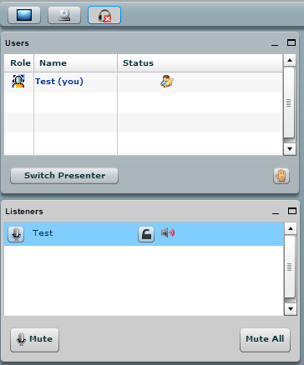
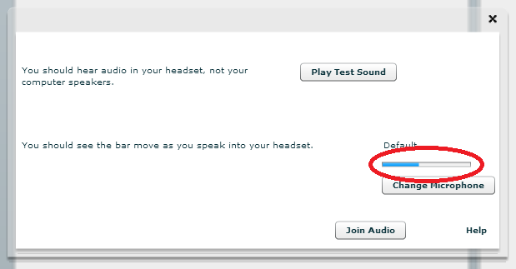
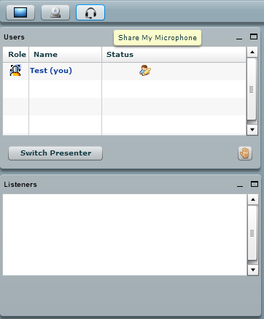

If you don’t see any energy register you will need to troubleshoot;

Instant chat
The instant chat allows the students to answer questions in text form and allows them to ask the teacher a question if they so choose to instead of using the voice chat. It can be useful if the student is asked to spell out words, construct sentences etc. The student can change their colour which helps the tutor to distinguish between the pupils and create a more personal atmosphere.
Video
In order to join the video chat the student will need to click the ‘Share my Camera button’ this will bring up a preview window where you can test the webcam. Within this window there are the following buttons.
Providing there is a camera connected, clicking this will share the camera with the rest of the users in the session. Once this has been clicked this icon will appear next to the users name in the user’s box.
If there is no video feed from the camera in the preview window this may be because a different camera needs to be selected this can be changed by clicking on the drop down menu and selecting another source

Interactive Whiteboard
The interactive whiteboard is flash based so relies heavily on Adobe Flash player, therefore this will need to be updated accordingly to make sure it is running the latest stable version.
The whiteboard can be used for teachers to upload presentations and demonstrate material they have prepared for the lesson. This enables the teacher to highlight and draw on the material which makes the learning process far more effective. Not only this, but the teacher can pass control over to a student. Even though the student is able to take control over the whiteboard the teacher is still in control of who is the presenter and can switch back any time. Whoever is in control of the whiteboard and is the presenter will have this icon next to their name in the user window.
To draw on the whiteboard you need to click this icon it will then bring up a toolbar on the right off the whiteboard which includes buttons to draw lines, circles and squares in whatever colour the user chooses.
Icons
Here are some of the other icons found on the platform;
This icon shows the lesson moderator. This will always be the teacher giving the lesson
This icon allows the student to communicate the fact they understand a topic or if they wish to answer a question just as they would in the classroom. It is a toggle button.

Troubleshooting
Steps for troubleshooting microphone issues
If you can hear the tutor but they cannot hear you follow the troubleshooting steps which follows;
- Check the microphone jacks/USB are plugged in correctly
- Make sure the microphone is not muted on a control piece
- Check microphone levels in Windows and in a sound manager if one is installed (e.g Realtek)
- Click change microphone when the popup appears after you join the listeners to choose from different microphone source connected to the computer.
If the headsets use USB, there might be a problem with the software drivers. IT personnel will need to attend to this.
When the student first joins into the listener’s box in the platform they will be muted by default. In order to unmute they just need to click on the icon, this will allow them to be heard by the rest of the listeners group and the icon will turn into its unmuted state .

Steps for troubleshooting headphone issues
If you cannot hear the tutor steps for troubleshooting are as follows;
- Check the headphone jack/USB is connected properly
- Make sure the headphones are not muted on a control piece
- Check the sound is not muted and the volume is up in windows
- Make sure the correct sound output device is selected in the popup after joining the listeners.

IT personnel Responsibilities
IT personnel have the following responsibilities to ensure the tute platform functions correctly on their computer systems.
These include;
- The responsibility to inform Tute of any changes that occur within the school regarding network infrastructure or upgrades etc.
- Ensuring that headsets are available for all students who participate in lessons which are in working order with sound settings configured correctly.
- Ensuring the latest stable version of flash player is installed.
- Ensuring all the workstations are on a wired connection to the schools LAN.

Headset are essential for learning process with Tute. If the students do not have access to them you can buy them from our recommended supplier for a discounted price. Please inform them you’re buying them to use with Tute.
sales@frostycow.co.uk

